CONSUMER DUTY FAIR VALUE ASSESSMENT

Date Conducted: July 20XX
Conducted By:
OBJECTIVE
In undertaking these Fair Value Assessments (FVAs) our objective is simply to demonstrate that our services deliver fair value to our target market.
SCOPE
Firm name is a firm of independent financial advisers which provides financial planning and mortgage advice services to retail clients.

SERVICES THAT ARE SUBJECT TO FVAs
Service | Target Market | Fees and Charges
Initial Advice Service (Financial Planning) | Any retail client requiring the setup of a regular premium pension | Typically 70% of the first years’ premiums
Initial Advice Service (Financial Planning) | Any retail client requiring a lump sum investment into a pension or investment | Typically 4% of the lump sum, subject to a minimum charge of £1,500.
Initial Advice Service (Financial Planning) | Any retail client requiring a pension annuity or similar | Typically 3% of the lump sum, subject to a minimum charge of £1,500.
Ongoing Review Services (Financial Planning):
Service 1 - | Any retail client with funds between £10,000 and £50,000 | 4% of the investment value (0.75% per annum)
Service 2 - | Any retail client with funds between £50,001 and £200,000 | 3% of the investment value (0.75% per annum)
Service 3 - | Any retail client with funds of £200,001 and above | 2% of the investment value (0.6% per annum)
Model Portfolio Service | Any retail client taking Service 2 and 3 as above. | Typically adds an additional charge of between 0.1%-0.2% to the ongoing fee as detailed above for Services 2 & 3.
Transaction Only (Life Assurance) | Any retail client requiring an insurance based product  Any sum assured | Equal to any commission received from the product provider  Min Fee typically £500
Mortgage Advice | Any consumer wanted to arrange a standard residential mortgage for house purchase, remortgage or buy to let | Equal to any commission received from the Lender  £499 advice fee

FAIR VALUE ASSESSMENT
We have completed a FVA for the service listed above.
Service | Target Market | Fees and Charges | Cost of Delivery
Initial Advice Service (Financial Planning) | Any retail client requiring the setup of a regular premium pension | Typically 70% of the first years’ premiums | £1074 (average cost per annum/per client)
 | Any retail client requiring a lump sum investment into a pension or investment | Typically 4% of the lump sum, subject to a minimum charge of £1,500 | £1074 (average cost per annum/per client)
 | Any retail client requiring a pension annuity or similar | Typically 3% of the lump sum, subject to a minimum charge of £1,500. | £1691 (average cost per annum/per client)
Ongoing Review Services (Financial Planning) | Service 1  Any retail client with funds between £10,000 and £50,000 | 4% of the investment value (0.75% per annum) | £613 (average cost per annum/per client)
 | Service 2  Any retail client with funds between £50,001 and £200,000 | 3% of the investment value (0.75% per annum)  0.1%-0.2% of the investment value for model portfolio service | £752 (average cost per annum/per client)
 | Service 3  Any retail client with funds of £200,001 and above | 2% of the investment value (0.6% per annum)  0.1%-0.2% of the investment value for model portfolio service | £1053 (average cost per annum/per client)
Transaction Only (Life Assurance) | Any retail client requiring an insurance based product / Any sum assured | Equal to any commission received from the product provider  Min Fee typically £500 | £1074 (average cost per annum/per client)
Mortgage Advice | Any consumer wanted to arrange a standard residential mortgage for house purchase, remortgage or buy to let | Equal to any commission received from the Lender  £499 advice fee | £1692 (average cost per client)

Service Features and Benefits
Financial Planning
Our services are designed for retail clients with varying levels of both attitude to risk and capacity for loss. Our CIP is managed by our Investment Committee (see PROD information). Asset allocation is used to align to client risk profiles. The firm provides an independent service.

Transaction Only (Life Assurance)
The cheapest monthly premium is recommended unless this is at odds with the client requirements. This product is sourced using IRESS.

Mortgages
The cheapest mortgage is recommended to the client based on their requirements. Cheapest can mean over a period of time, cheapest interest rate, cheapest monthly payment, total cost inclusive of fees. This will be defined as part of the KYC exercise and applied when sourcing the product using MBL.
Fees and Charges
When benchmarked across the industry, the total fees and charges is comparable. Our services are in line with firms of a similar size and business model. For the advice charge levied, the client receives a formal assessment of suitability, generally delivered face-2-face, when KYC, risk profiles, objectives and cashflow (where appropriate) are fully reviewed, and following which a full Suitability Report is issued. The advice team are always available to take client questions or respond to concerns.
Performance
Performance of our CIP over 1, 3 and 5 years has been unexceptional and in line with industry benchmarks (see separate data) and in line with the objectives of the portfolio. Portfolio performance (excluding new contributions) exceeds the total fees paid by the client for all FUM amounts. Net growth after fees and charges exceeds inflation over the 5 year period, although there was one year in this period where growth was less than inflation.

Cost of Delivery
Appendix 1 below shows the cost of deliver for both initial and ongoing services. Each has been broken down based on complexity (i.e. simple, moderate and complex), with a complexity weighting applied for both moderate and complex cases. Our interpretation of these labels has been documented with the help of our external compliance support. We have applied a profit margin of 30% across the board in line with our business strategy.
Client Feedback
Client feedback demonstrates satisfied or very satisfied outcomes evidenced by this being expressed by clients and the continued personal introductions that we receive from existing clients.
Overall Assessment
Do fees and charges provide fair value? | Given the level of service provided, the performance of the portfolio, client feedback and the fact that fees and charges do not exceed the cost of delivery excessively, it is our opinion that the service continues to provide fair value.
Are fees and charges in line with industry norms? | Yes.
Are fees and charges in line with similar firms? | Yes.
Are the benefits and features in line with target market requirements? | Yes, we believe that they meet target market requirements.
Are there some clients in this target market that may benefit from a lower charging service? | Client requirements are reviewed on an ongoing basis.
Has performance been in line with expectations? | Yes. See separate data.
Has client feedback or complaints highlighted any concerns? | No negative feedback has been received from in excess of 1400 clients with an ongoing advice service
Action Plan for Improvement
Nothing at this time.

Appendix 1

New Business – Product Simple

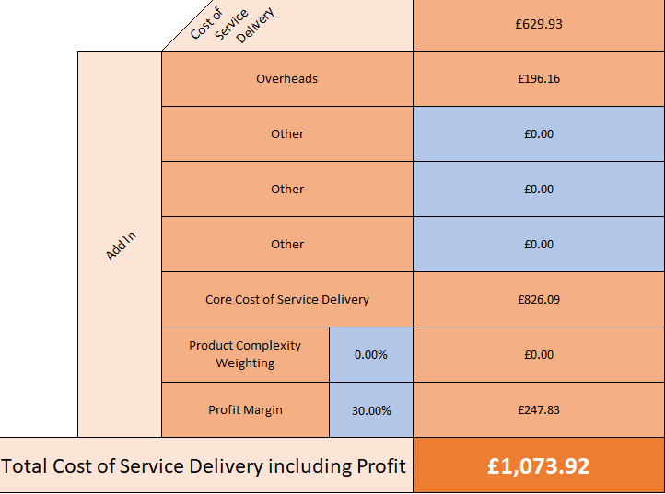

New Business – Product Moderate

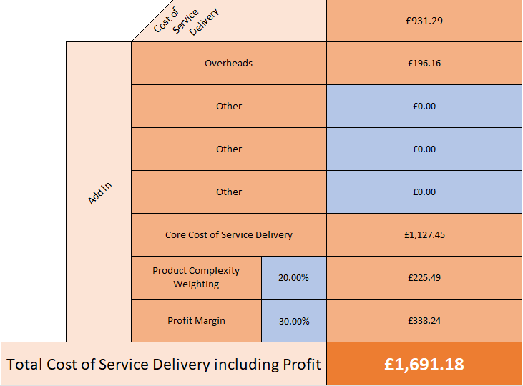

New Business – Product Complex

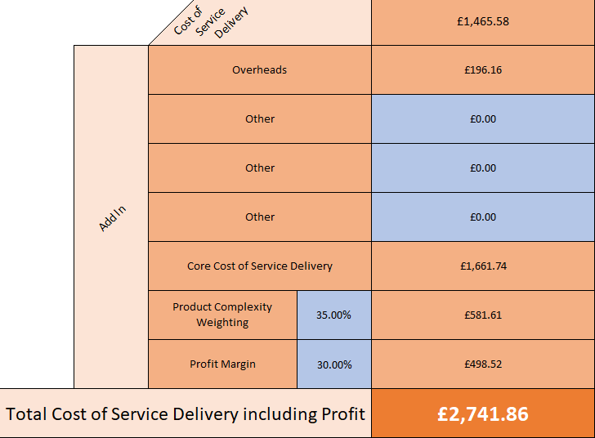

Client Review – Simple

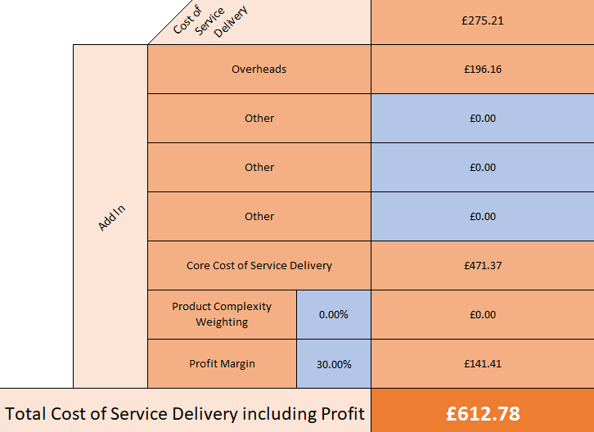

Client Review – Moderate

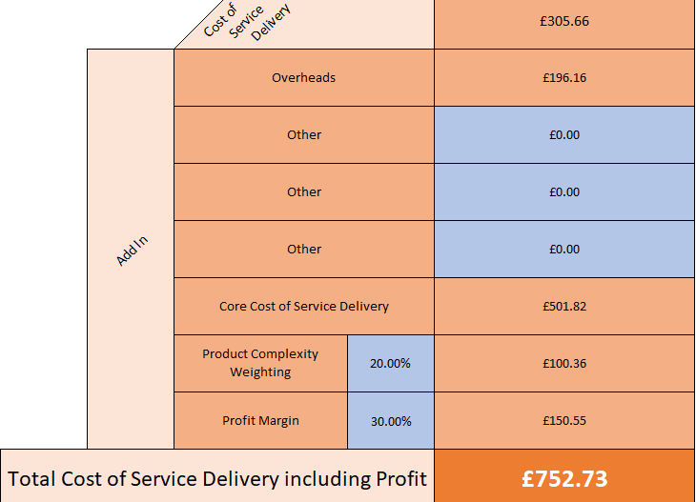

Client Review – Complex

